Background color:

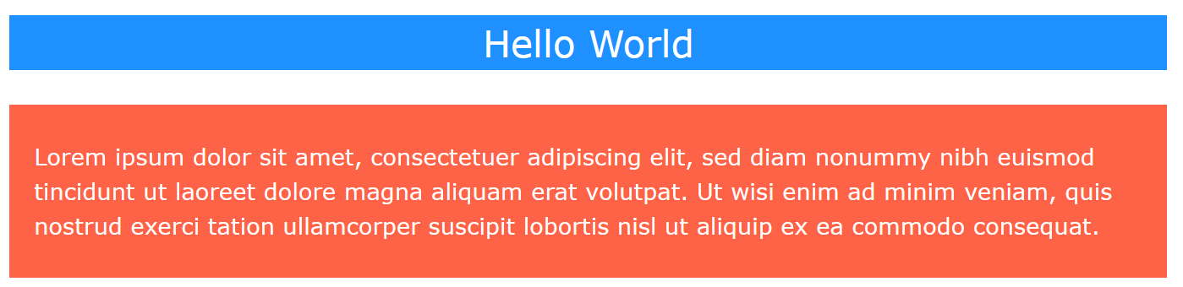

<h1 style="background-color:DodgerBlue;">Hello World</h1>  
<p style="background-color:Tomato;">Lorem ipsum...</p>

Text color:

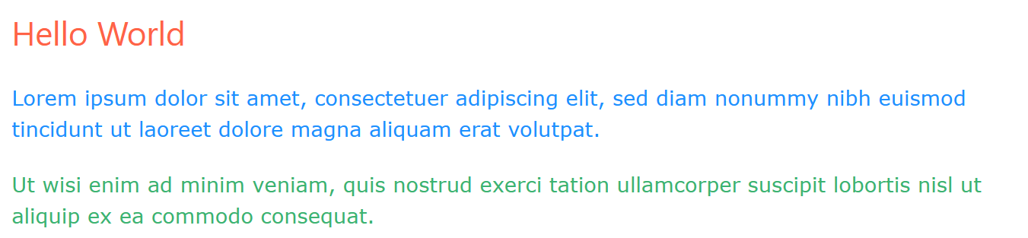

<h1 style="color:Tomato;">Hello World</h1>  
<p style="color:DodgerBlue;">Lorem ipsum...</p>  
<p style="color:MediumSeaGreen;">Ut wisi enim...</p>

Centering an Image:

.center {  
  display: block;  
  margin-left: auto;  
  margin-right: auto;  
  width: 50%;  
}